Dynperf Performance Agent

Usage Cheat sheet

Step 1 – Open Copilot from within Dynamics 365 Finance and Operations



Step 2 – Trigger the Keywords to launch the Agent

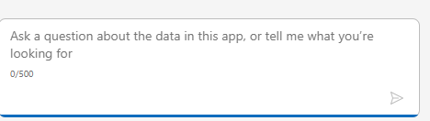

Can use the following Keywords:
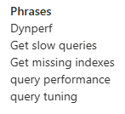
Step 3 – Enter the parameters to search Query Data Store

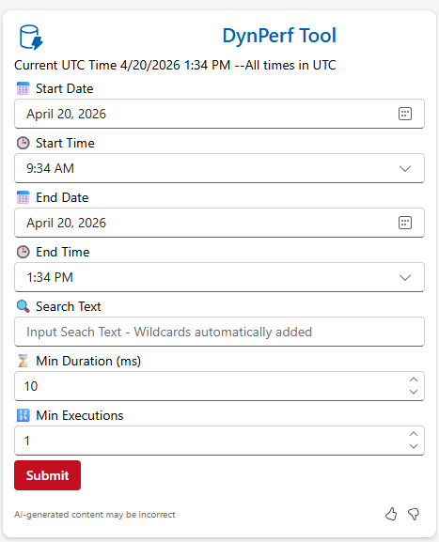

Start Date and Start Time Default to 4 hours ago UTC
End Date and End Time Default to current UTC time.
Note: Query Data Store contains data for weeks potentially

Search Text:
This parameter provides the most flexibility in finding queries. Beginning and Ending Wildcards are not necessary as that is being added automatically:

Option 1: Enter Table/EntityName to find queries with a specific table in the query
SalesTable

Option 2: Enter MissingIndex to get list of queries that have a missing index hint
MissingIndex

Option 3: Enter Index Scan to get a list of queries that have an Index Scan in the query plan
Index Scan

Option 4: Combine the above(The wildcard Is necessary in this case)
SALESTABLE%Missing Index

Option 5: Find 2 tables in the same query
SALESTABLE%SALESLINE

Min Duration:
This parameter helps in finding queries that are running over xxxxx(ms). This helps find those LONG running queries.
For Example:
1000 (greater than 1 second)

Min Executions:
This parameter helps in finding highly active queries. This is to help eliminate the one off user created query (bad search for example)

